**Project Executable Files (Project Files)**

|  |  |
| --- | --- |
| **Date** | 25 JUNE 2025 |
| **Team ID** | LTVIP2025TMID31613 |
| **Project Name** | Garage Management System |
| **Maximum Marks** |  |

This is a **Salesforce-based implementation**, so the "executables" are not traditional .exe files but configurations and custom code within the Salesforce ecosystem. The project includes:

**A.Custom Salesforce Objects:**

Created via salesforce setup**:**

**Account:**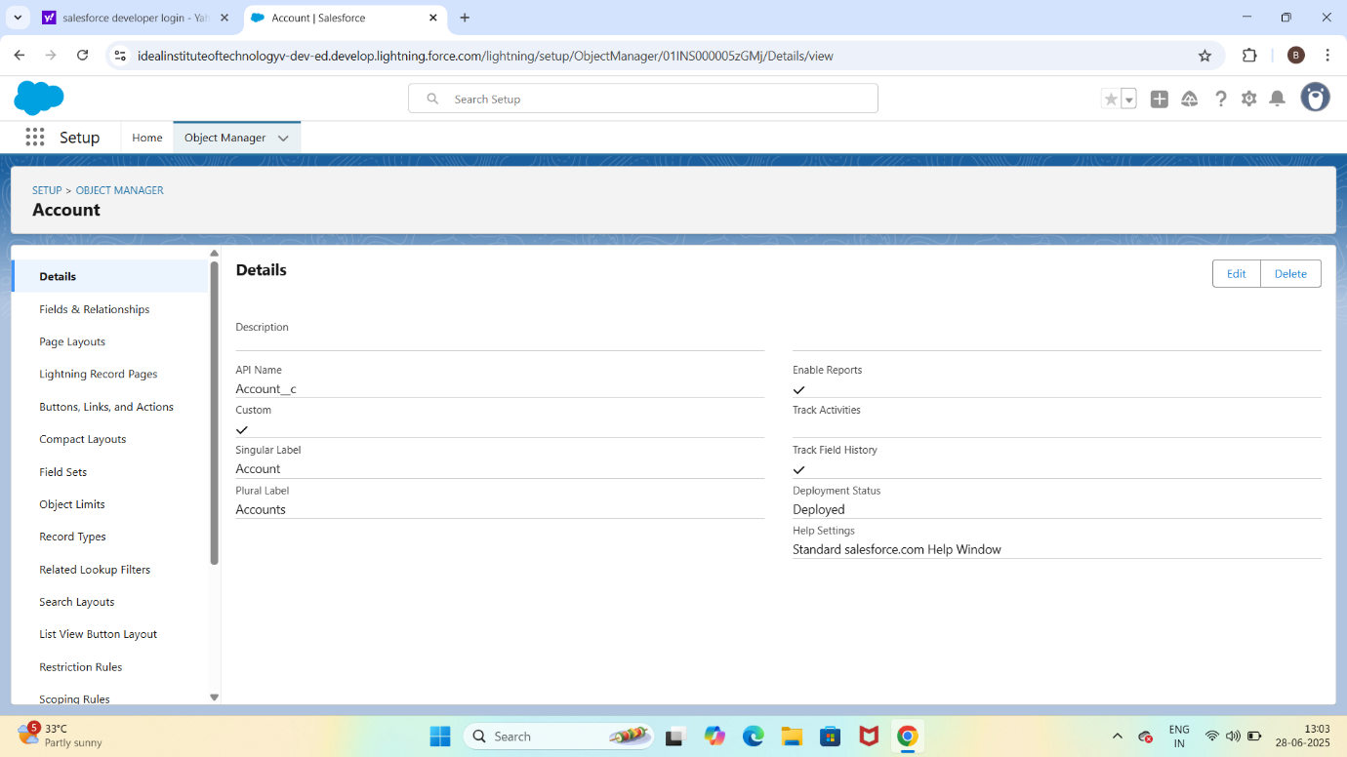

**Appointment:**

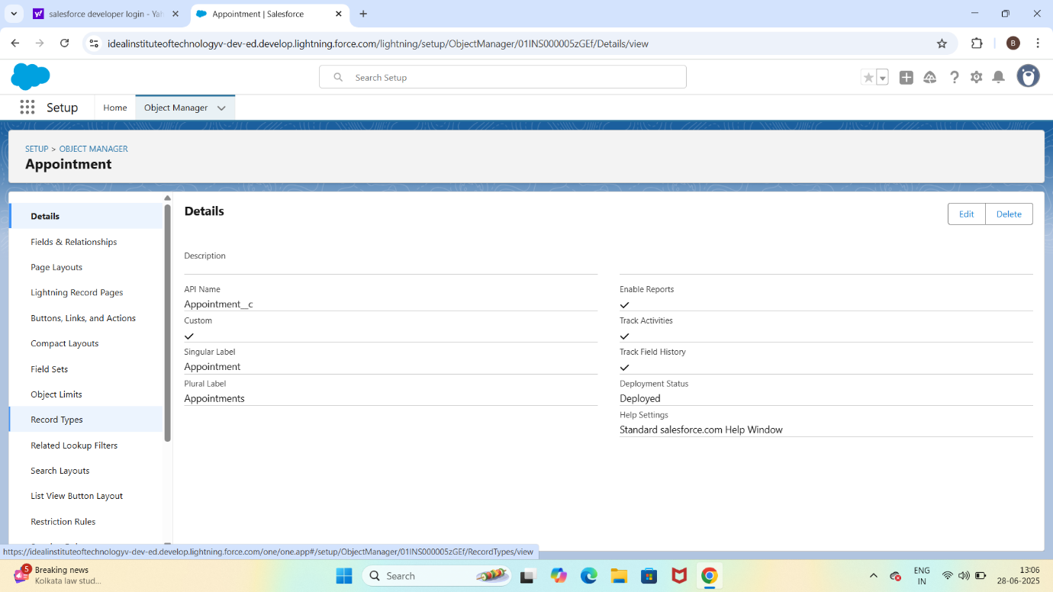

**B.Custom Tabs and APP:**

Tabs for each object

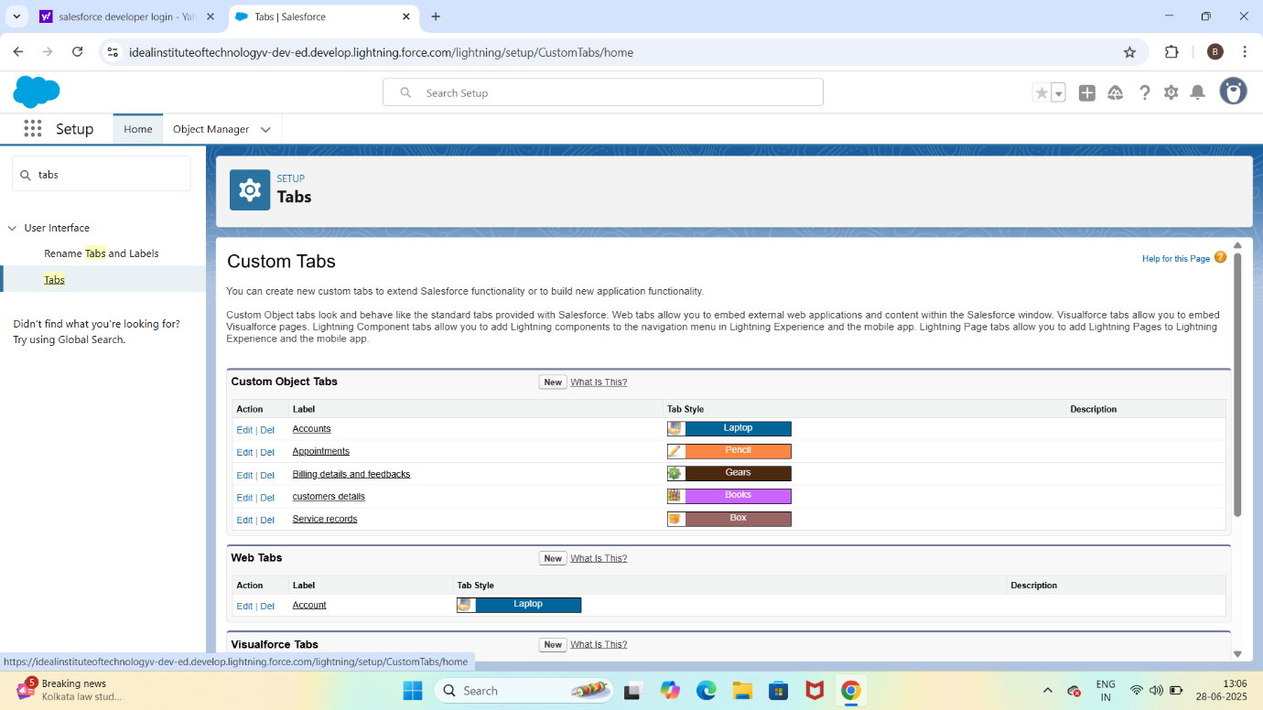

**Lightning app:**

A lightning app called lease management with navigation setup

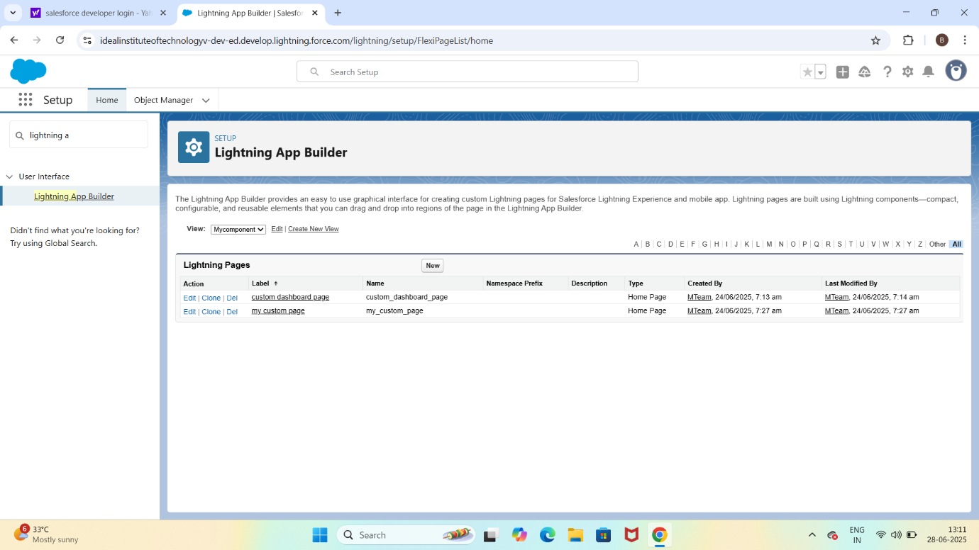

**C.Fields and Relationships**:

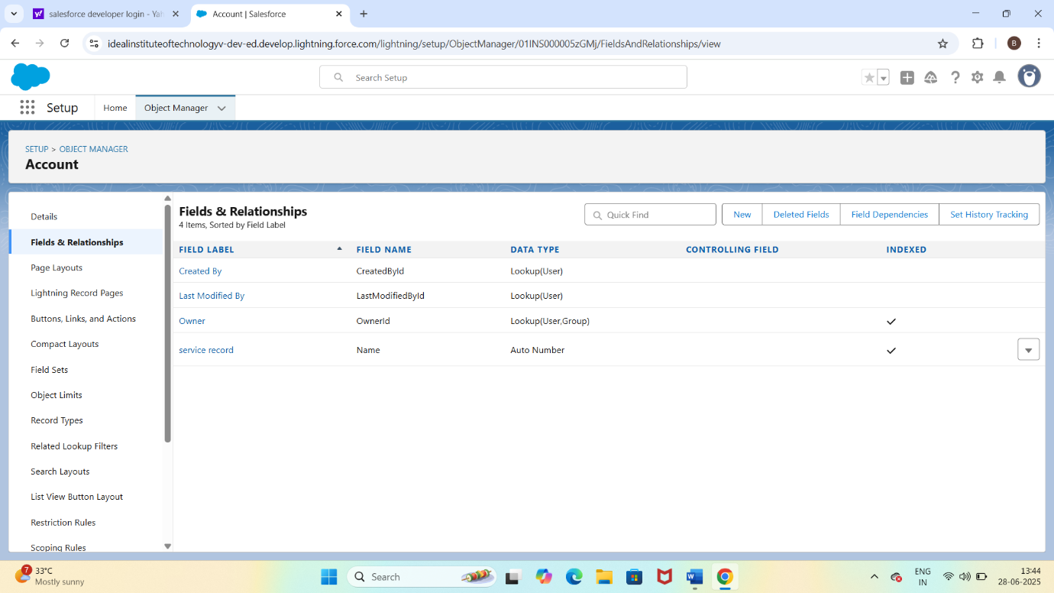

**D.Apex Code(Custom Backend logic):**

**Apex Class:**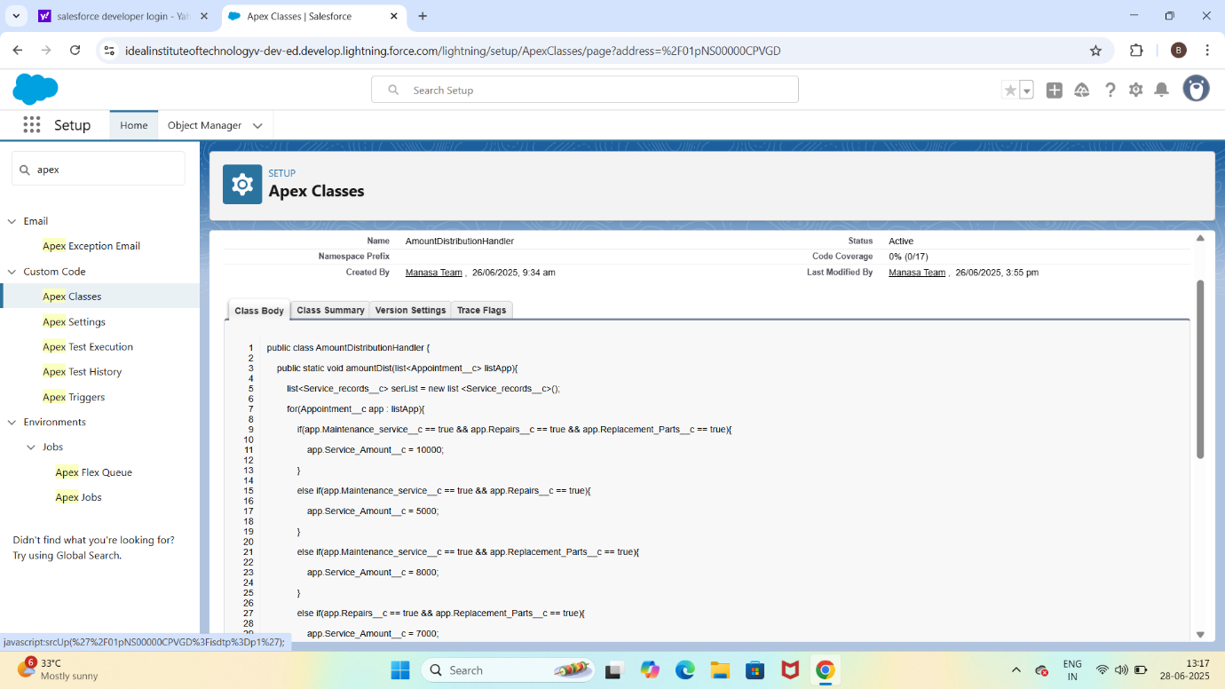

**Apex Trigger:**

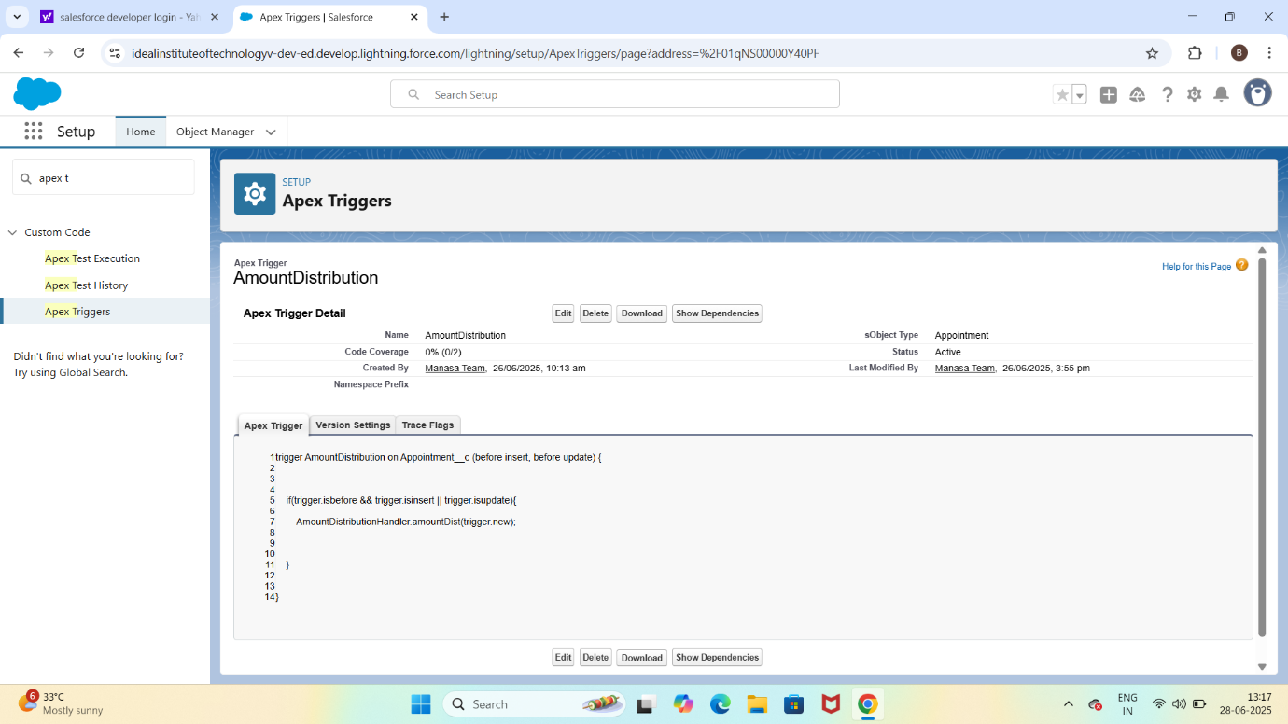

**E.Validation Rule:**

Appointment object has a rule: End_date__c > Start_date__c

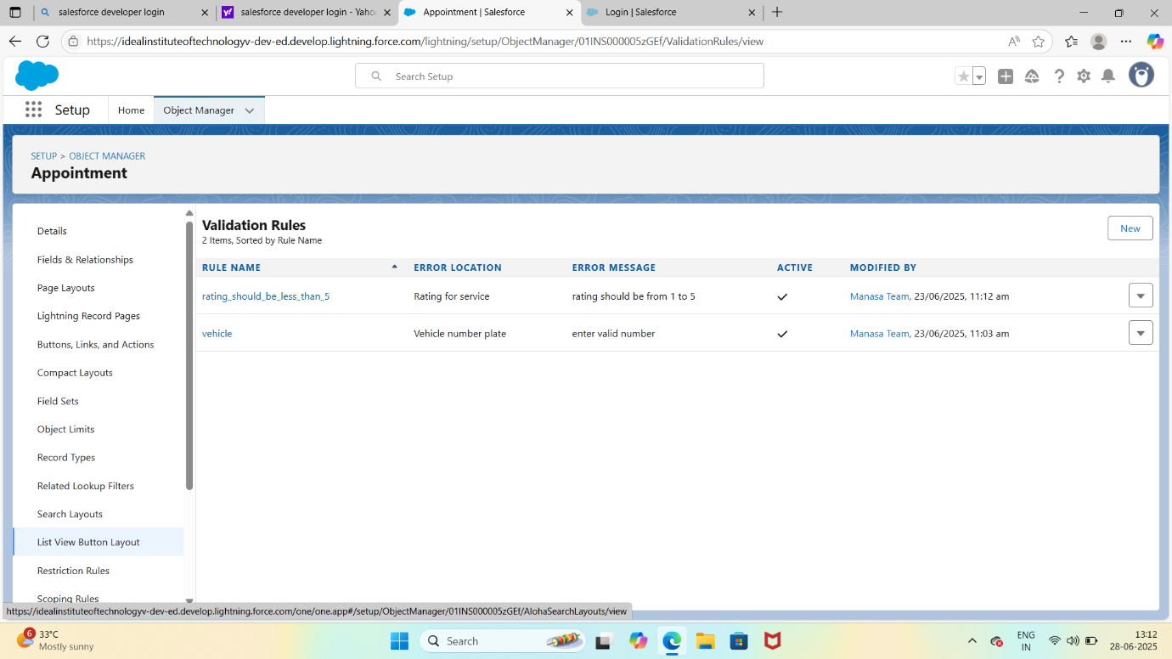

**F.Flows:**

